“Forte Mining Supply” LLC was established in August 2011 to serve the needs of the mining and steel fabrication industries by providing general engineering services after sales of conveyor components and accessories, welding, safety supplies, drilling and lifting equipment.

Forte Mining Supply is committed to providing these industries with top-quality products and solutions.

We are able to draw on a vast pool of technical knowledge of the parent company in the areas below:

1. Bulk conveyor components and accessories
2. Welding products
3. Safety Products - Selection & Correct Use of Products
4. Rigging & Lifting Gear
5. Steel Fabrication
6. General Engineering Needs

**Distributor agreements**

“Forte Mining Supply” LLC has distribution agreements with the following worldwide manufacturers and also we are supplying goods from Russia and China:

1. ASGCO Manufacturing – Conveyor components and accessories
2. Thermadyne Ltd (Cigweld) – Welding Machines & Consumables
3. Hobart Brothers Co – Welding Machines & Consumables
4. Miller Electric – Welding Machines & Consumables
5. MSA Australia Pty Ltd – Safety Supplies
6. Elliot Australia – Safety Supplies

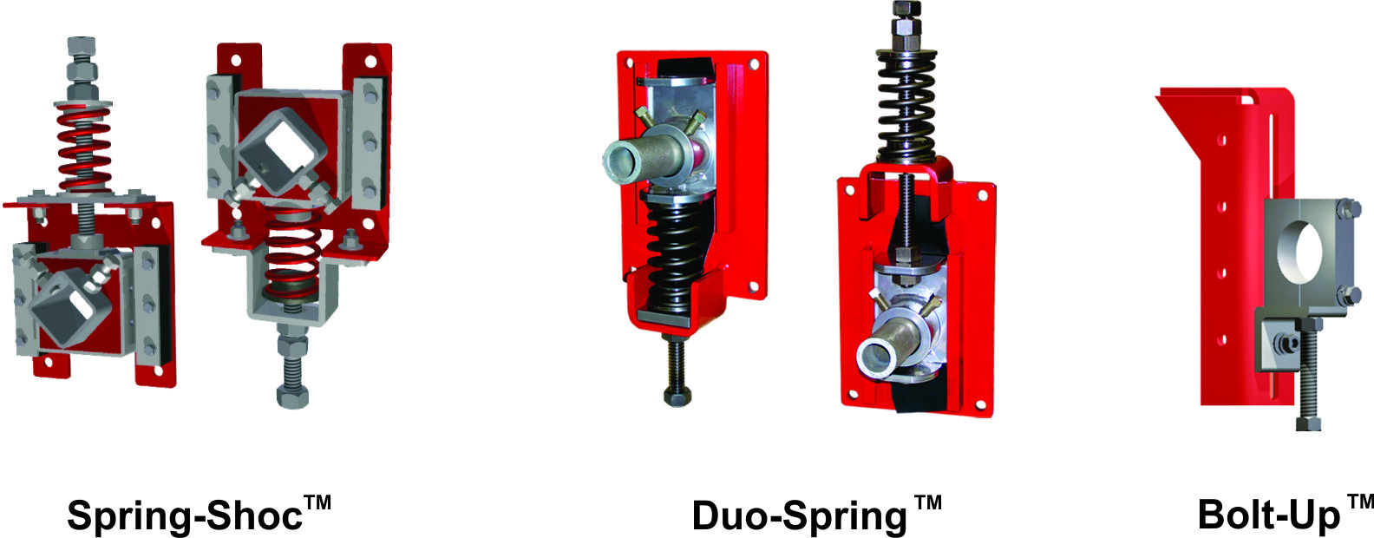

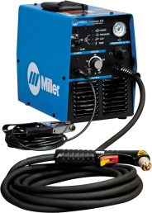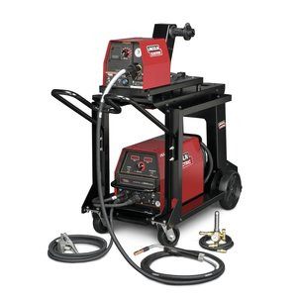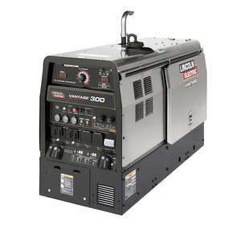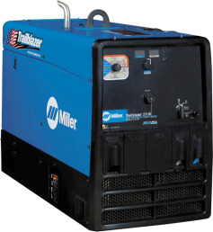

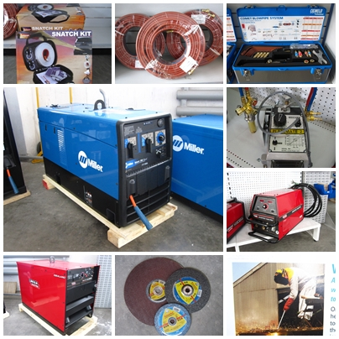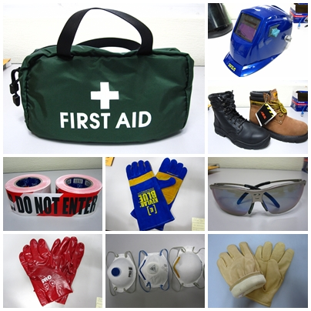

These worldwide manufactures offer state-of-the-art equipment at competitive prices. Forte Mining Supply is proud to be a supplier of these high-quality industrial products.

## Statement of Quality Assurance

All items which are sold by Forte Mining Supply LLC are made to the industry standards for quality by their manufacturers, and periodical checks of quality are undertaken by Forte Mining Supply. Reports from the manufacturers are available upon request.

Where a defective item is found, the manufacturer’s warranty will apply and Forte Mining Supply will give all the assistance deemed necessary to keep the Customer satisfied.

If found that an item required by the Customer and supplied by Forte Mining Supply does not meet the Customer’s requirements, then the item will be replaced.

If quality problems are encountered, a notice will be given to the manufacturer to address the fault and repair or replacement of faulty items will be carried out.

## Pricing statement

We are able to provide a good discount structure with all our major suppliers and these discounts are available to Forte Mining Supply Customers.

These discounts are reviewed on an annual basis with our Suppliers.

Fixed prices can be established for a specific time, if required by our Customers under contract agreements.

## Technical statement

Forte Mining Supply LLC can assist, in conjunction with our Suppliers, in the preparation of welding procedures for full and semi-automatic welding, as well as manual metal arc welding. This can be done for any type of welding project.

Forte Mining Supply continually improve our service by better understanding your business and priorities. Taking a consultive approach to business partnerships, our individual account management provides industry and technical specialists who are equipped with the tools, systems technology and processes necessary to provide Customers with excellent services.

Our team of trained and experienced product experts with decades of practical experience will help Customers choose the best product for their job.

If your business is looking for a wide range of competitive pricing, fast and accurate deliveries and knowledgeable and experienced people, then Forte Mining Supply LLC has all your needs.

Since establishment, our company has been supplying goods to some of Mongolia’s largest companies in the mining, drilling, and welding industries such as:

1. “Oyu Tolgoi” LLC
2. Mongolian Gold” LLC
3. Leighton
4. Energy Resource
5. Transwest Mongolia
6. Variety of local companies

**Management and employees**

At present, we have a total of 6 full-time and 2 part-time employees at Forte Mining Supply LLC, including:

* Managing Director
* Accountant
* Sales and Office Administrator
* Salesman

Warehouse

Our company is planning to construct a 300 square meter of store house in Bayangol District and it will be put into operation on November, 2016.

Contacts:

Khantulga Tsembel [khantulga@forte.m](mailto:khantulga@forte.m)n

“Forte Mining Supply” LLC

Sukhbaatar district, 1st khoroo, Chinggis avenue-15,

NCP bldg, Suite No.602

Phone/Fax: 70104575, Mobile: 99996623